 | Project Design Phase-II
 | Data Flow Diagram &User Stories
Date |  | 13 October 2022
Team ID |  | PNT2022TMID13098
Project Name |  | Project – Car Resale Value Prediction
Maximum Marks |  | 4 Marks

Data Flow Diagrams:

A Data Flow Diagram (DFD) is a traditional visual representation of the information flows within a system. A neat and clear DFD can depict the right amount of the system requirement graphically. It shows how data enters and leaves the system, what changes the information, and where data is stored.
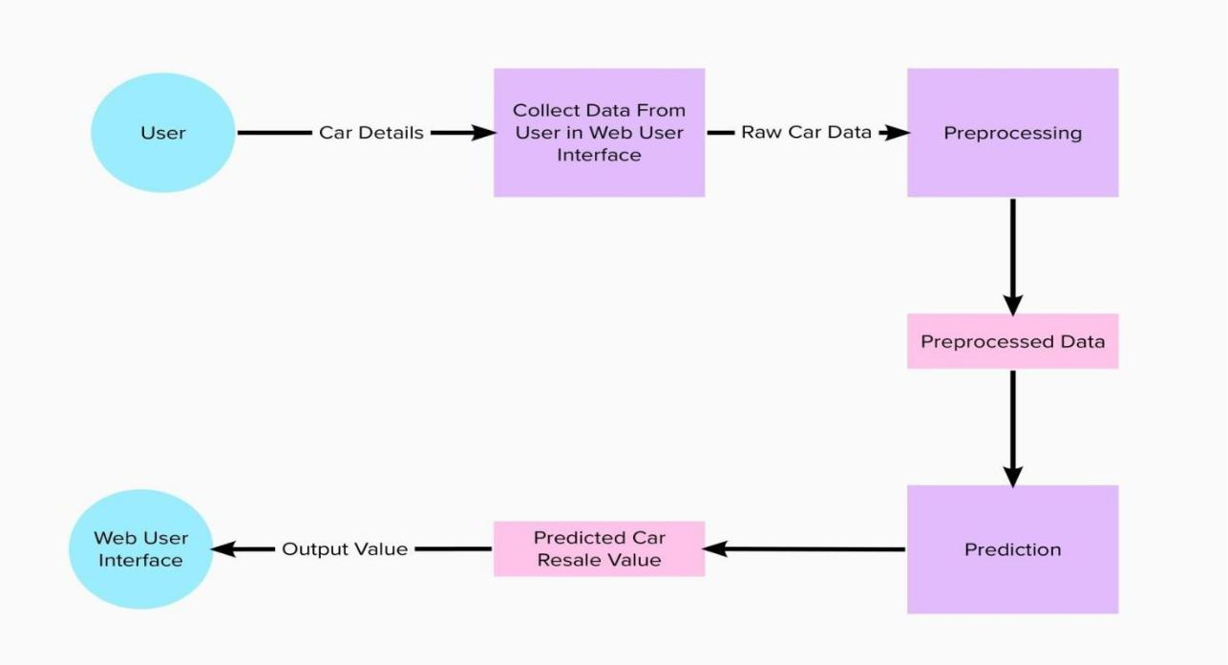
User Stories

User Type | Functional | User Story | User Story / Task | Acceptance criteria | Priority | Release
 | Requirement | Number
 | (Epic)
Customer | Registration | USN-1 | As a user, I can register by entering my email, | I can access my account / | High | Sprint-1
(web user) |  |  | password, and confirming my password. | dashboard
 |  | USN-2 | As a user, I will receive confirmation email | I can receive confirmation | High | Sprint-1
 |  |  | once I have registered for the | email & click confirm
 |  | USN-3 | As a user, I can register through Face book | I can register & access the | Low | Sprint-2
 |  |  |  | dashboard with Facebook
 |  |  |  | Login
 |  | USN-4 | As a user, I can register for the through Gmail | I can register through | Medium | Sprint-1
 |  |  |  | Gmail
 | Login | USN-5 | As a user, I can login by entering email & | I can login by my login | High | Sprint-1
 |  |  | password | details
 | Dashboard
 | Data entry | USN-1 | As a user, I can enter the card details | I can enter the details of | Medium | Sprint-1
 |  |  |  | the card
 | Obtain output | USN-2 | As a user I’ll receive car resale value | I can receive my car | High | Sprint-1
 |  |  |  | resale value

